**MACM 316 – Computing Assignment 2 Report**

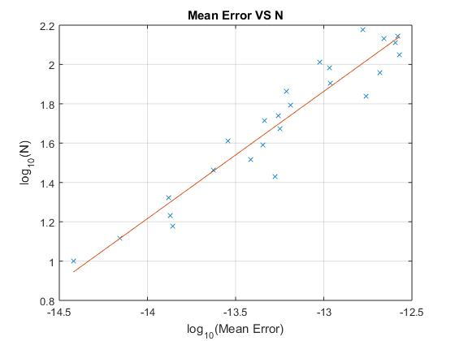As stated on the assignment pdf, usual personal computers do not have the memory or processing power to find n* exactly, so we need to take several sample points and run it several times to extrapolate the behaviour of the data and eventually have an estimation on n*. Essentially, I created a vector of 25 integers range within 10 to 150, which was sufficient enough to draw a best fit line on the data using polyfit( ). The reason why I set the value N ranging within 10 to 150 was because if N was set to be 1, then the mean error would become 0 which would cause outputting infinity after taking the log operation. So I simply chose N with a starting value of 10 just to avoid having the situation described above. Also the reason why I chose the maximum value of N to be 150 was because values greater than 150 would relatively take longer time to run the script due to the increasing size of matrix causing increasing computational time. Furthermore, I chose number of trials Ntr to be 300 was also because this value would provide potentially correct results while the computational time was not dramatically slow.

I used the polyfit function to draw out the best fit line of the sample points after plotting the sample points showing as the blue points on the figure of log10(EN) versus log10(N) above, and then I calculated its slope and y-intercept which would allow me to approximate log10(N*). The slope of the linear line was 0.5169 and the y-intercept was 8.5277. Therefore, from solving the equation log10(N*) = 8.5277, we get N* equals to 108.5277 which is N* ≈ 109 where the mean error EN ≈ 1.  
  
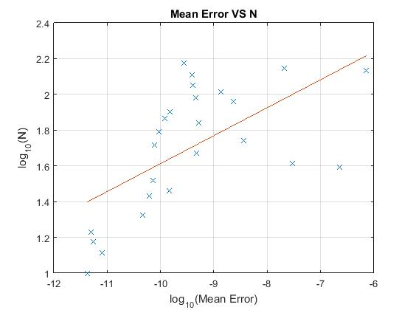

I chose N and Ntr to be the same values as the previous one just so they could potentially provide correct results while the computational time did not take up too long to run. For the extrapolation of the data, I also use the polyfit function to draw out a best fit line among the points on the figure. I calculated its slope and y-intercept as well and I got the value slope = 0.1564 and the y-intercept = 3.1766. Therefore, from solving the equation log10(N*) = 3.1766, we get N* equals to 103.1766 which is N* ≈ 103 where the mean error EN ≈ 1.

As you can see from the figure above, the points are not as stable as the points showing up on the previous figure. Part of the reasons why this happened was due to the multiplication of A transpose and A which had the big values of A gone bigger and the small values of A gone smaller. Therefore the error relatively increases.